**UNIVERSITATEA OVIDIUS DIN CONSTANȚA**

**FACULTATEA DE MATEMATICĂ ȘI INFORMATICĂ**

**MACHINE LEARNING - PROJECT 2**

**Student:**

**Arsenie Mihai**

**CONSTANȚA 2024**

# Dataset

About the dataset

Dataset link: https://www.kaggle.com/datasets/misrakahmed/vegetable-image-dataset/data

This is a dataset that contains pictures of different vegetables. The vegetables that are chosen for the experimentation are- bean, bitter gourd, bottle gourd, brinjal, broccoli, cabbage, capsicum, carrot, cauliflower, cucumber, papaya, potato, pumpkin, radish and tomato. A total of 21000 images from 15 classes are used where each class contains 1400 images of size 224×224 and in *.jpg format. The dataset split 70%(1000 images) for training, 15%(200 images) for validation, and 15%(200 images) for testing purpose.

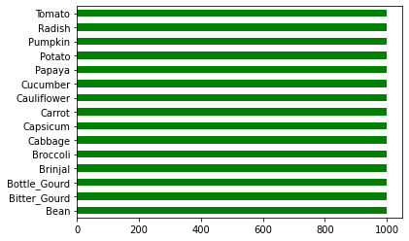

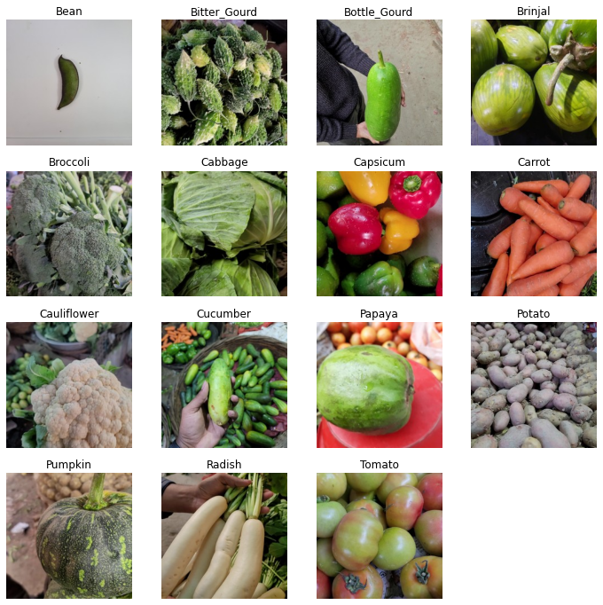

# Data generators for training, validation and testing

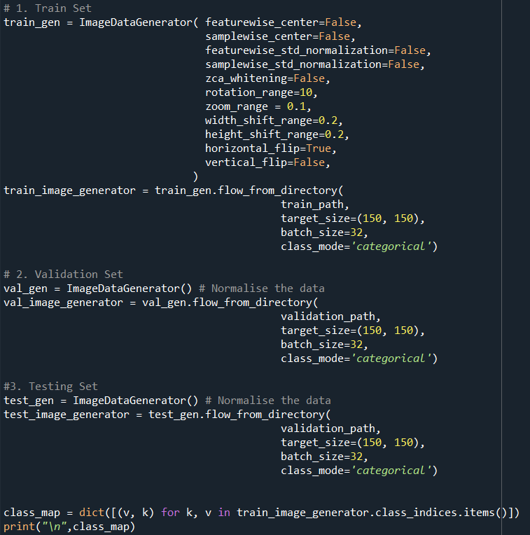

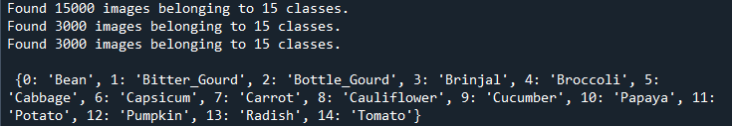

These generators facilitate efficient loading and preprocessing of images during training, validation, and testing of a deep learning model.

# Image classification

I used a CNN model for image classification with convolutional layers for feature extraction, fully connected layers for classification, and appropriate activation functions for each layer. The model is designed to classify input images into one of 15 classes.

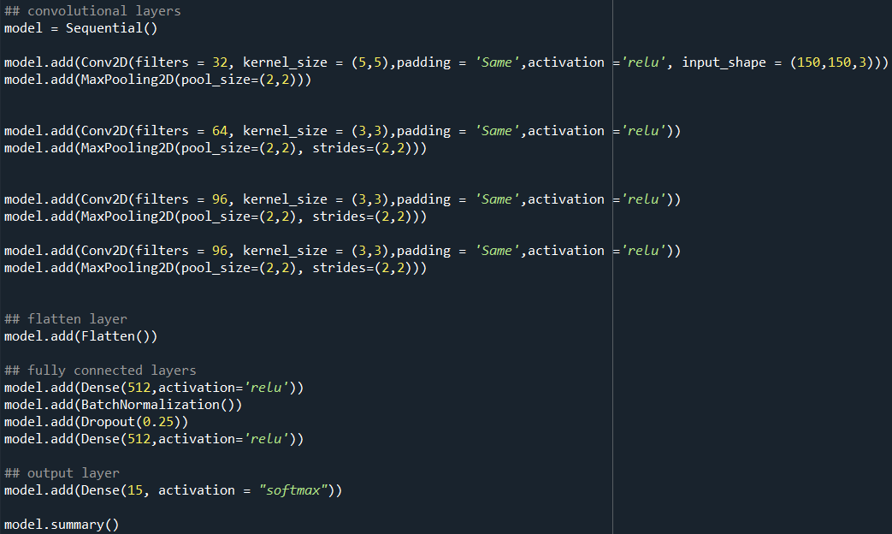

Model architecture

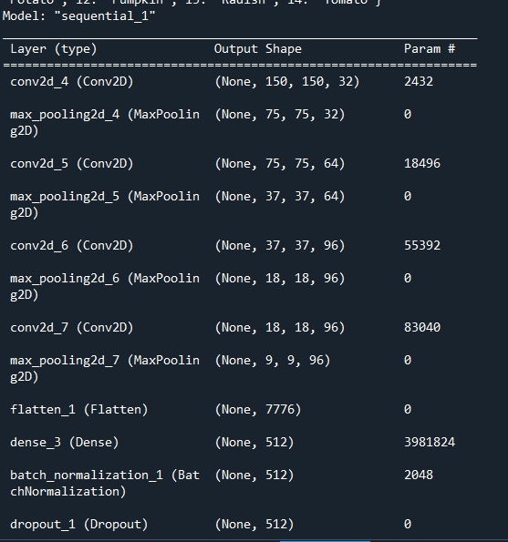

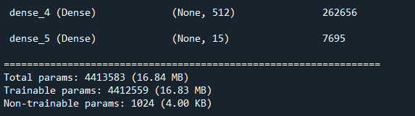

# Compiling the Model

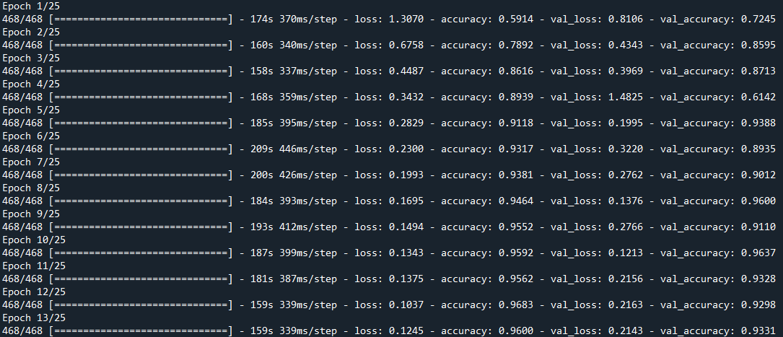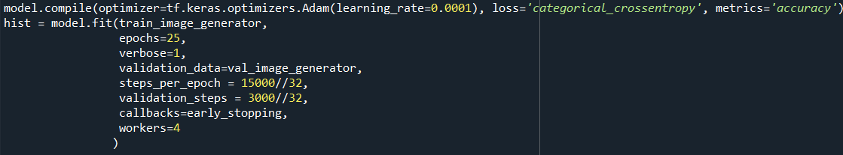In this section, the model is compiled and then trained using the training and validation data.

# Model Accuracy and Loss

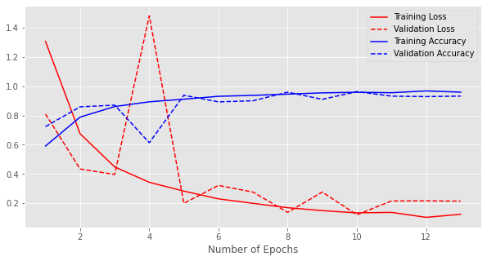

# Predict

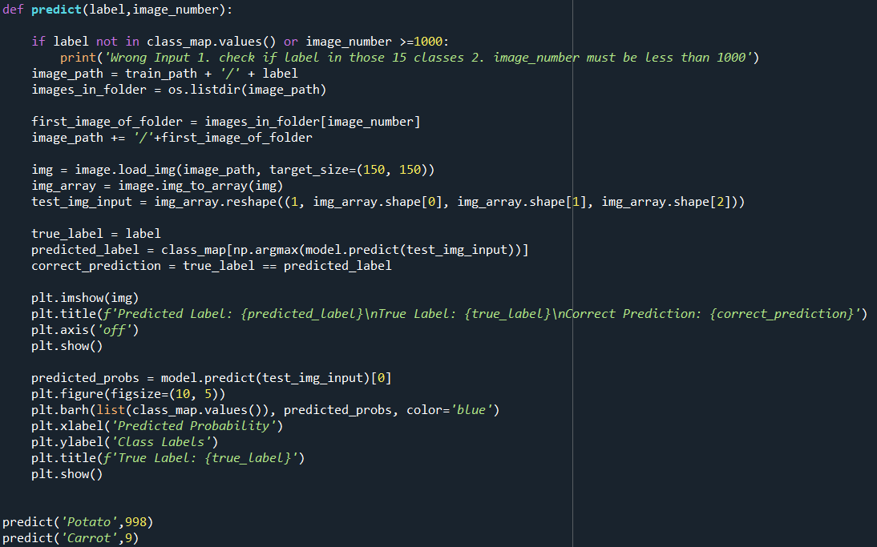

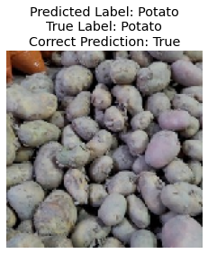

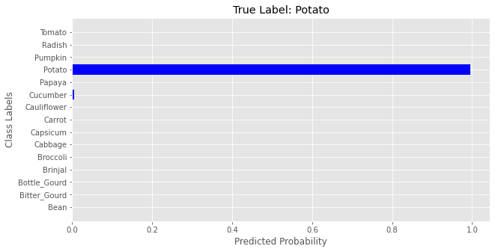

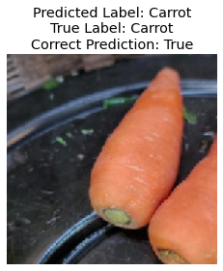

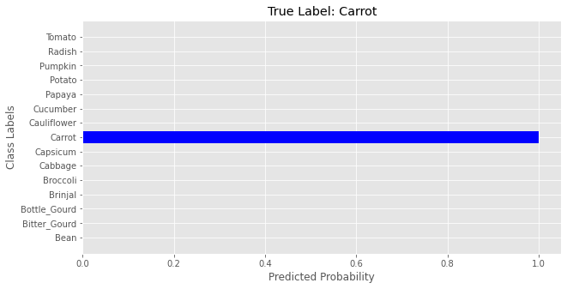

# Model with 1 epoch

